Using Stepper Motors

by [lady ada](https://learn.adafruit.com/users/adafruit2)

In this example we'll wire up and use a bi-polar stepper motor with recommended 12V motor voltage, and 200 steps per rotation.

[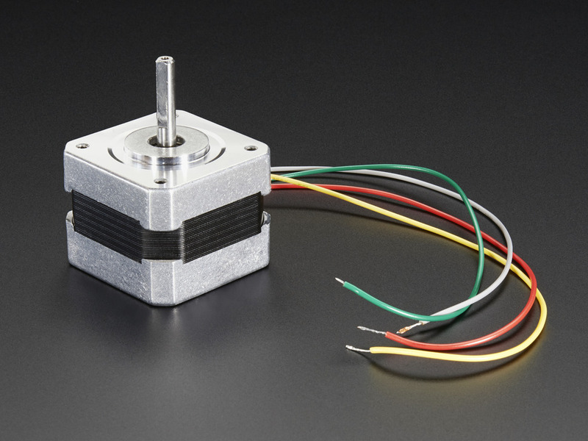](https://learn.adafruit.com/assets/24261)

Wiring

We'll wire it to a Metro, but you can use any microcontroller you like!

Connect:

* **Vmotor** to 12V (red wire)
* **Vcc** to 5V (orange wire)
* **GND** to ground
* **AIN2** to Digital 4
* **AIN1** to Digital 5
* **BIN1** to Digital 6
* **BIN2** to Digital 7
* **PWMA** and **PWMB** to Vcc (orange wire)

Then hook one stepper motor coil to **Motor A** (red and yellow) and the second coil to **Motor B** (green and gray/brown). If you have another motor, you'll need to experiment a little to figure out which wires are which coil. Check any documentation you have! You can use a multimeter to measure between wires, the ones with a small resistance between them are a pair to a coil, for example. If the motor is vibrating but not spinning, check all wires are connected and try flipping around a pair or rechecking the wire pairs.

If you have a unipolar motor, there will be a 5th or 6th wire that is the 'common' wire. Connect these wires to the GND pins in between the Motor A and B outputs on the breakout.

[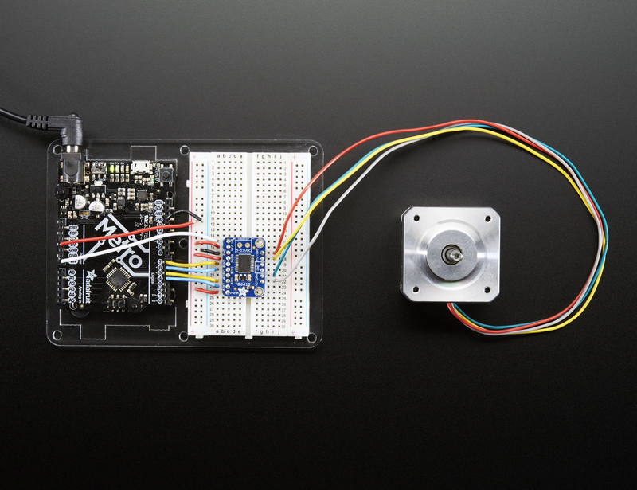](https://learn.adafruit.com/assets/31945)

Software

[We'll use the built-in Arduino Stepper library](http://arduino.cc/en/Reference/Stepper), but you can manually toggle the AIN1/AIN2/BIN1/BIN2 pins with your own favorite microcontroller setup

[Download file](https://learn.adafruit.com/pages/5429/elements/1754992/download)

[Copy Code](https://learn.adafruit.com/adafruit-tb6612-h-bridge-dc-stepper-motor-driver-breakout/using-stepper-motors)

1. #include <Stepper.h>
3. // change this to the number of steps on your motor
4. #define STEPS 200
6. // create an instance of the stepper class, specifying
7. // the number of steps of the motor and the pins it's
8. // attached to
9. Stepper stepper(STEPS, 4, 5, 6, 7);

12. void setup()
13. {
14. Serial.begin(9600);
15. Serial.println("Stepper test!");
16. // set the speed of the motor to 30 RPMs
17. stepper.setSpeed(60);
18. }
20. void loop()
21. {
22. Serial.println("Forward");
23. stepper.step(STEPS);
24. Serial.println("Backward");
25. stepper.step(-STEPS);
26. }

Basically after you make the **Stepper** object with the 4 control pins, you can set the rotational speed (in RPM) with **setSpeed(*rpm*)**and then step forward or backwards with **.step(*steps*)** where *steps* is positive for 'forward' and negative for 'backward'

[For more details, check out the Stepper library](http://arduino.cc/en/Reference/Stepper)